**NAAN MUDHALVAN**

**PROJECT TITLE**

**UNLOCKING INSIGHTS INTO THE GLOBAL AIR TRANSPORTATION NETWORK WITH TABLEAU.**

**TEAM LEADER**

**S. EZHILKUMAR**

**TEAM MEMBERS**

**T.DHANUSH**

**M.GOPALAKRISHNA GOKALE**

**E.GNANASEKARI**

**OUR GUIDE : C. SELVAKUMAR**

**OCKING INSIGHTS INTO THE GLOBAL AIR TRANSPORTATION NETWORK WITH TABLEAU.**

1. **Introduction** 
   1. **Overview:**
   2. **Purpose:**
2. **Problem statement & design thinking**
   1. **Empathy map**
   2. **Ideation and brinstorming map**
3. **Result**
4. **Advantages & disadvantages**
5. **Application**
6. **Future scope**

**INTRODUCTION:**

This Global Air Transportation Network dataset is a comprehensive collection of information on airports, airlines and their routes. It contains information such as names, cities, countries, codes (IATA and ICAO) longitudes, latitudes and altitudes of airports across the world with detailed time zone and daylight saving time data. Additionally, this includes information about airlines including their IDs, name aliases, IATA and ICAO codes, callsigns country of origin and active/inactive status. Similarly, it also covers route details such as airline sources to destination airports along with essential details like codeshare stakeholder if any stops required during this journey along with the type of aircraft being used for that particular journey. This dataset has been compiled through meticulous labor by researchers all over the world to give you a comprehensive detail into air transportation networks from around the globe.

**OVERVIEW:**

The air transport network is a key infrastructure asset. It is the only worldwide passenger and cargo transportation network, providing an essential link between individual countries and the wider global economy.

**PURPOSE:**

IATA aims to be the force for value creation and innovation driving a safe, secure and profitable air transport industry that sustainably connects and enriches the world. IATA's mission is to represent, lead, and serve the airline industry.

**Empathy map:**

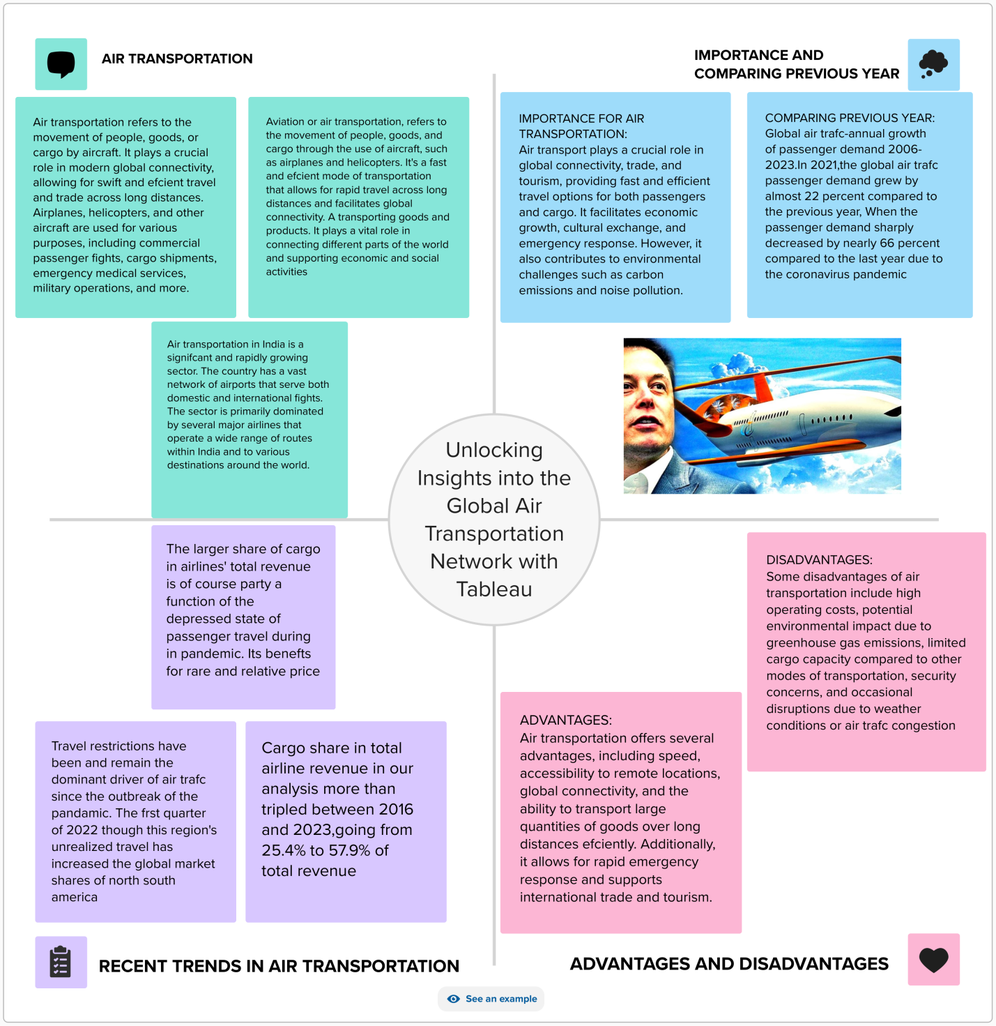

**Ideation and brainstorming map:**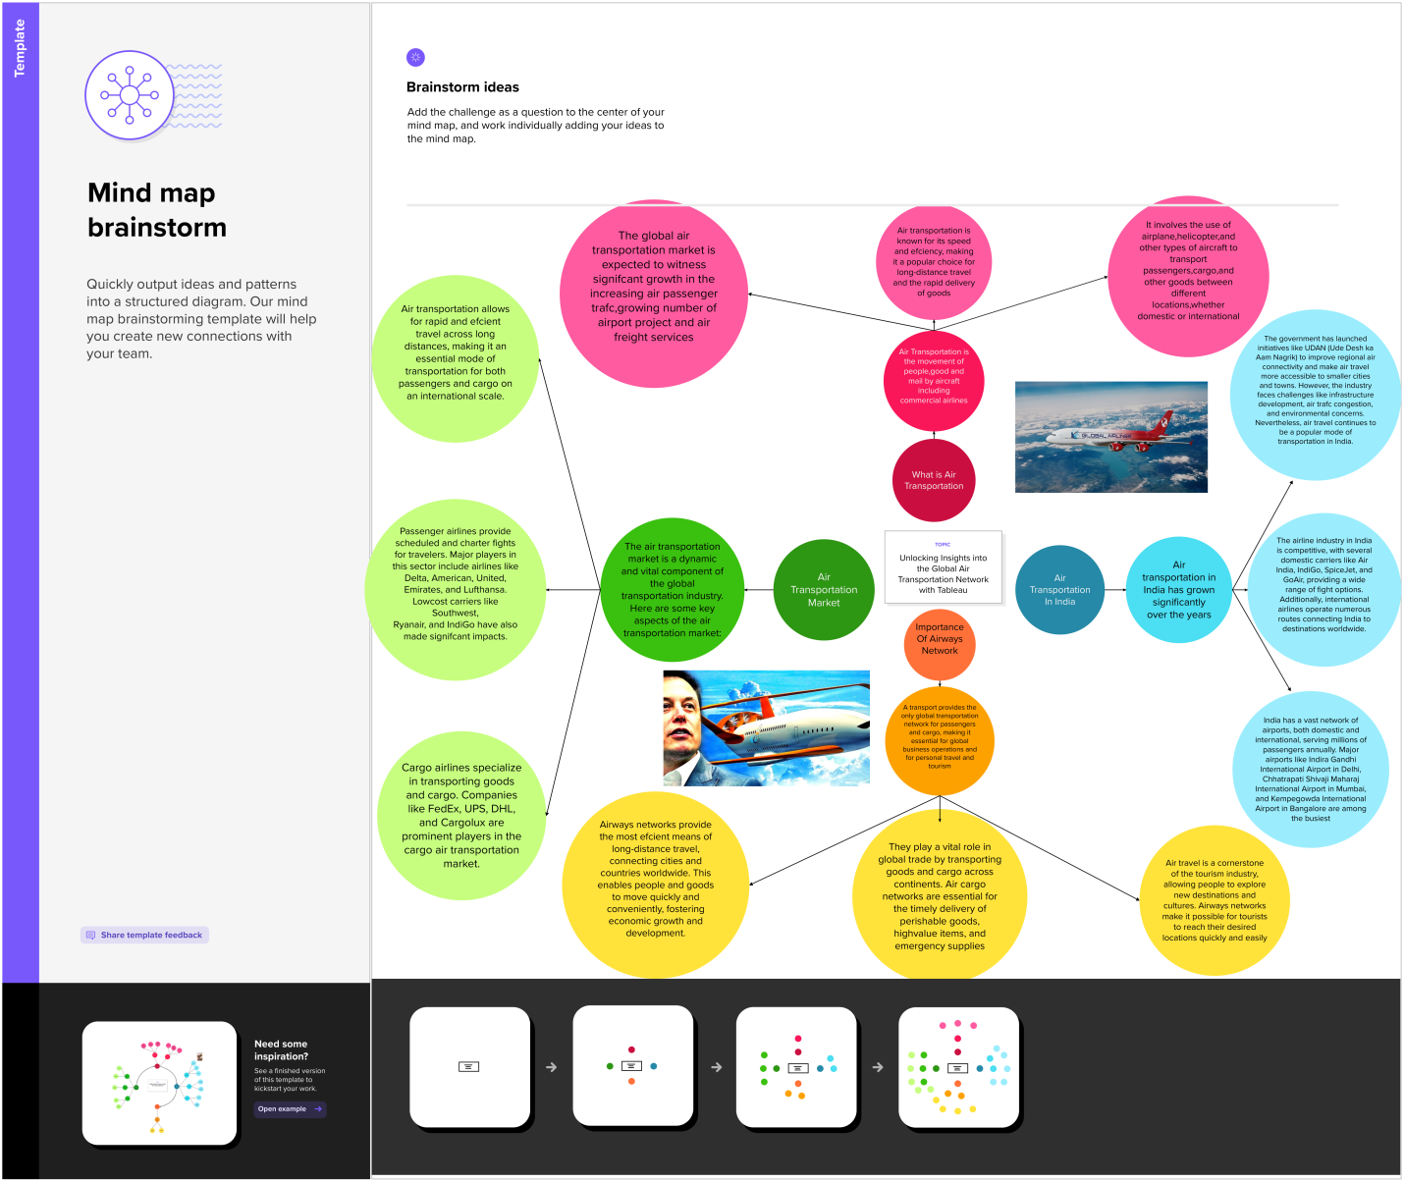

**Result: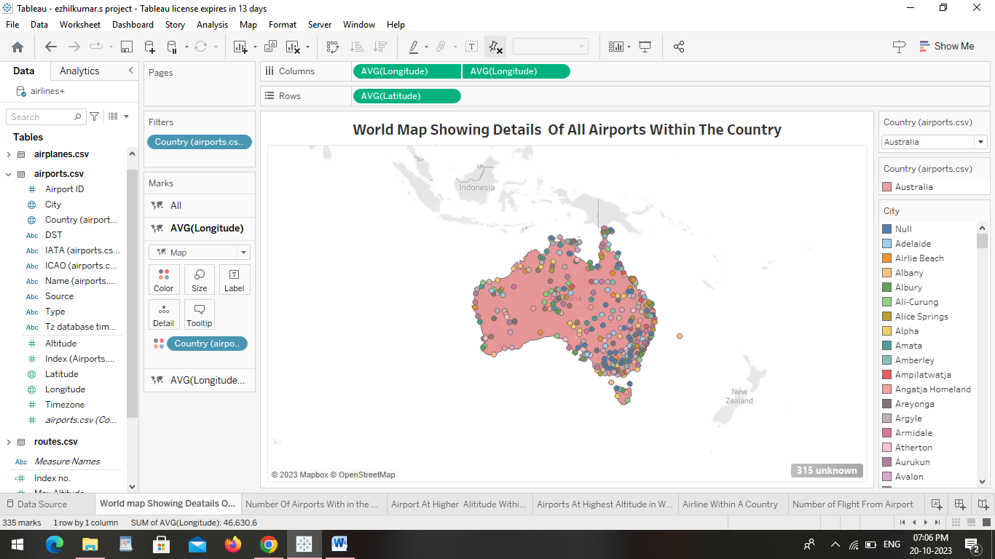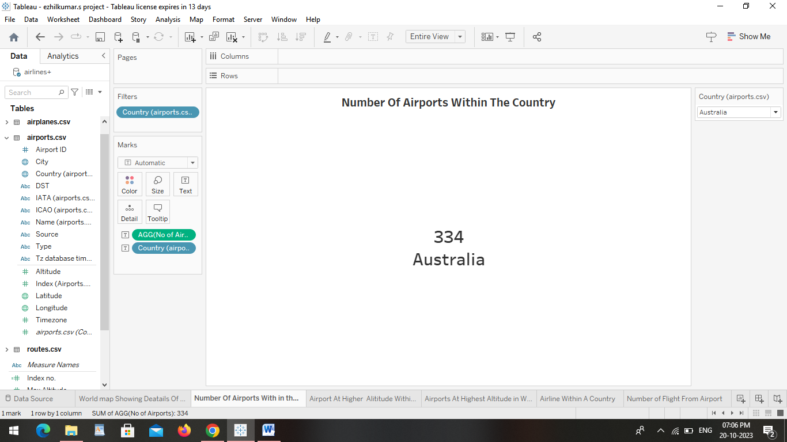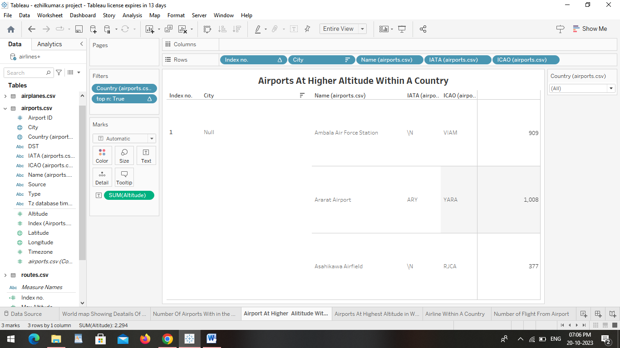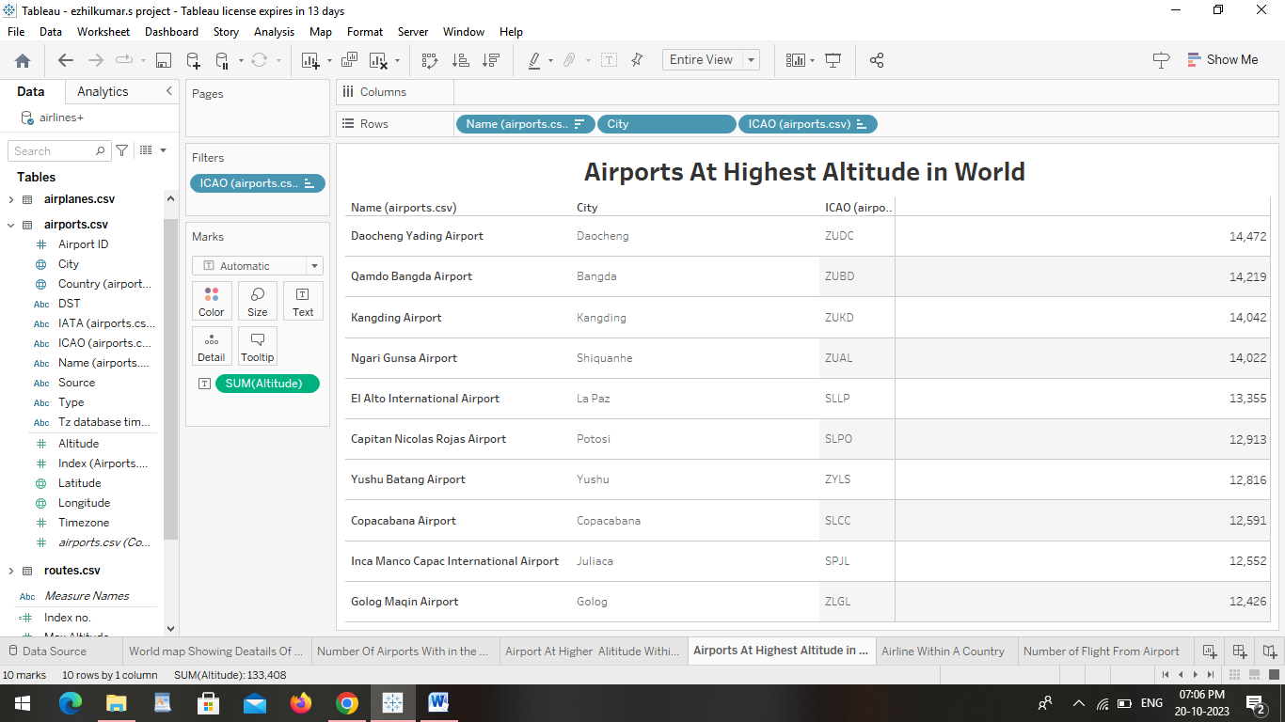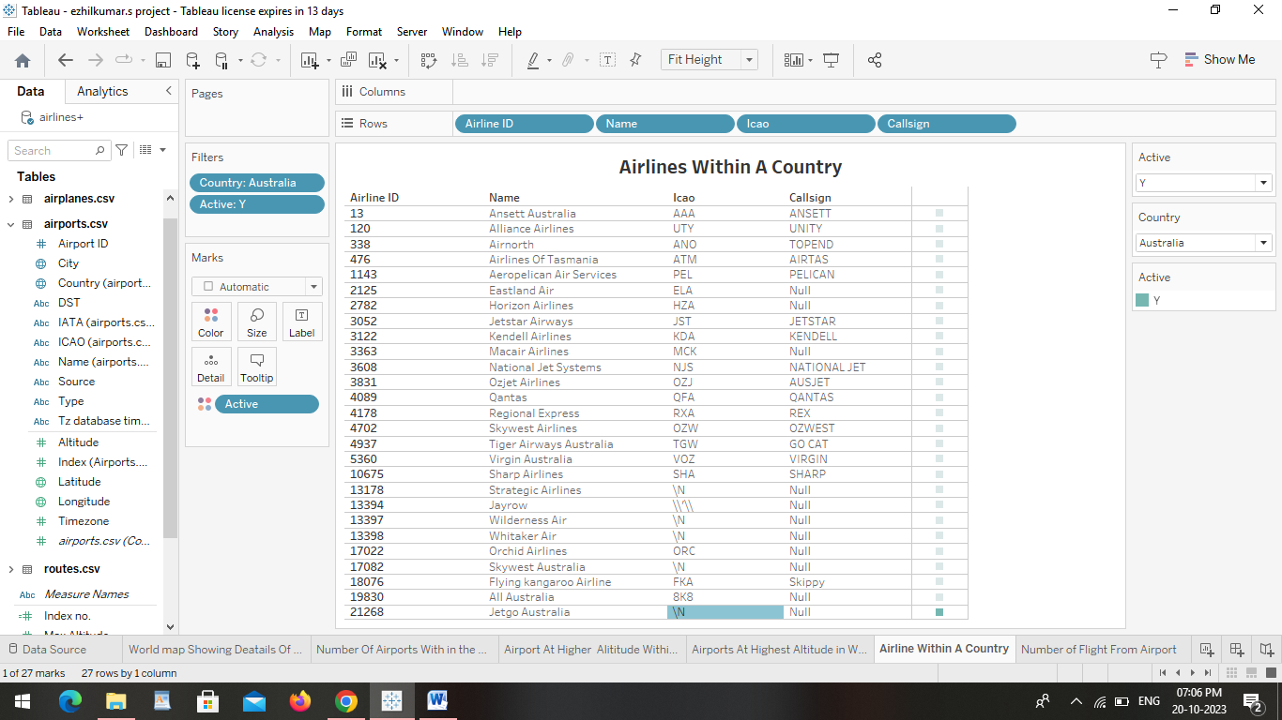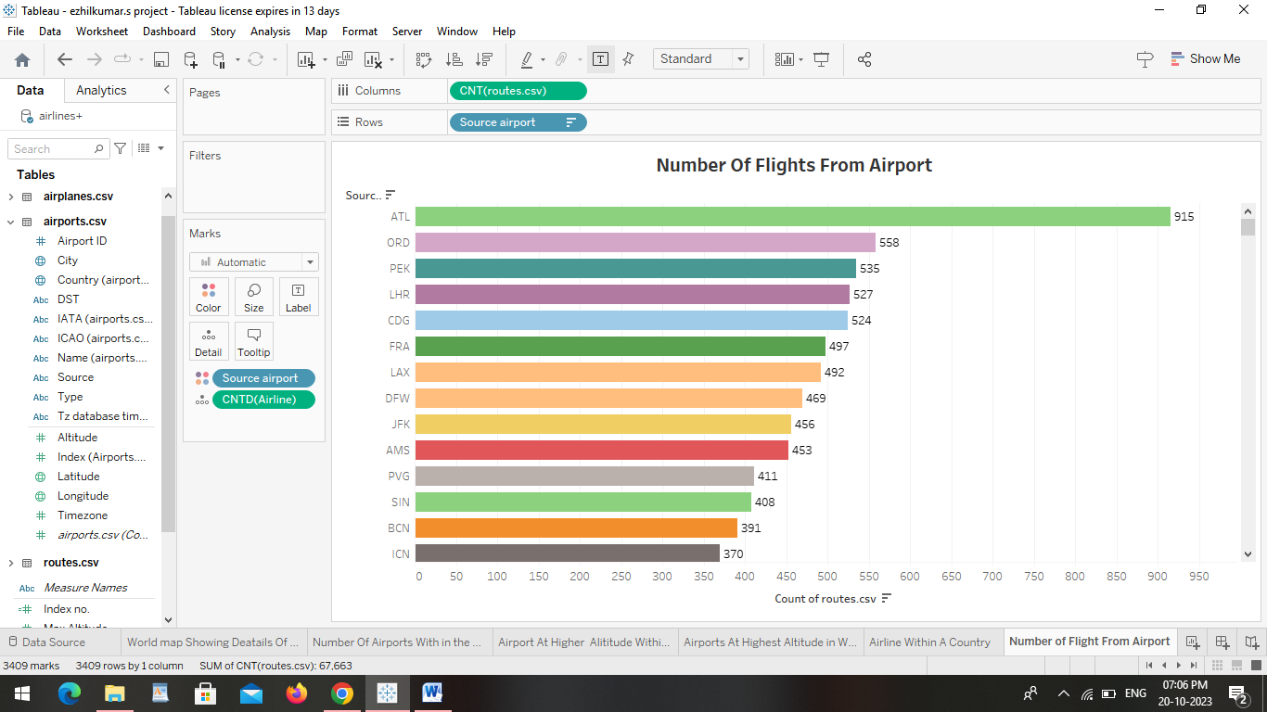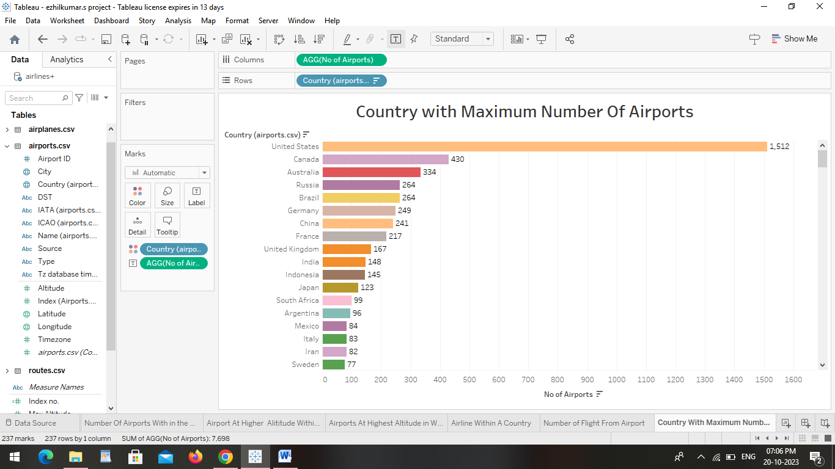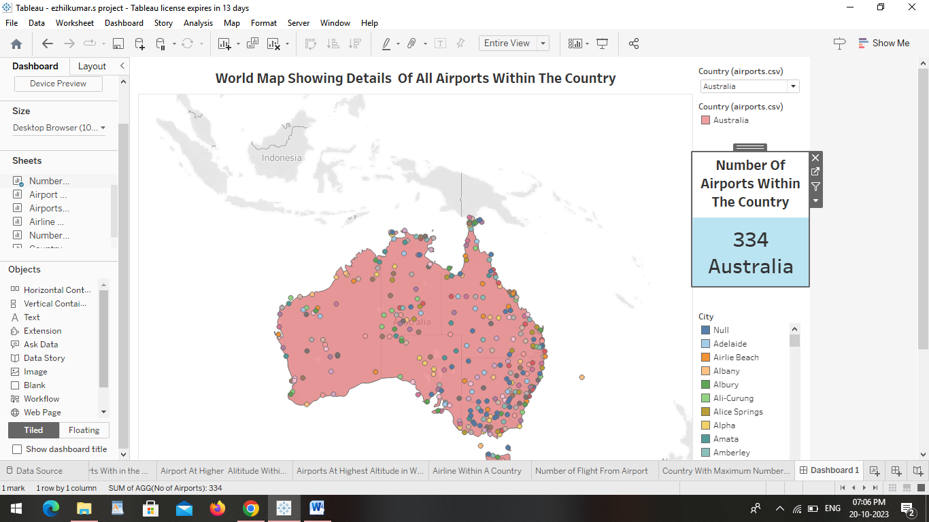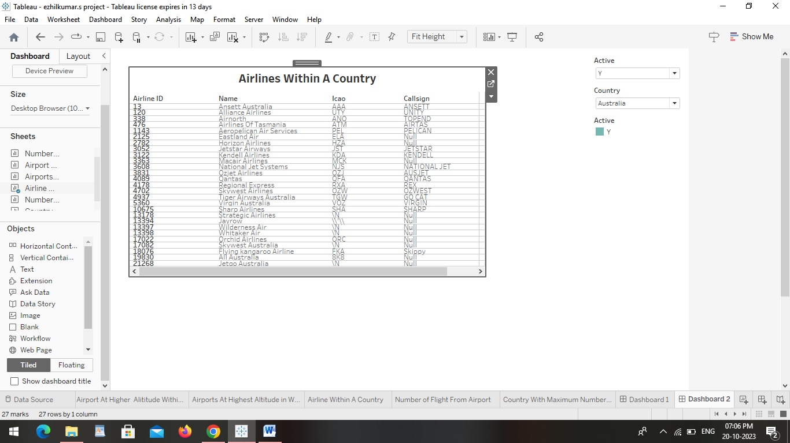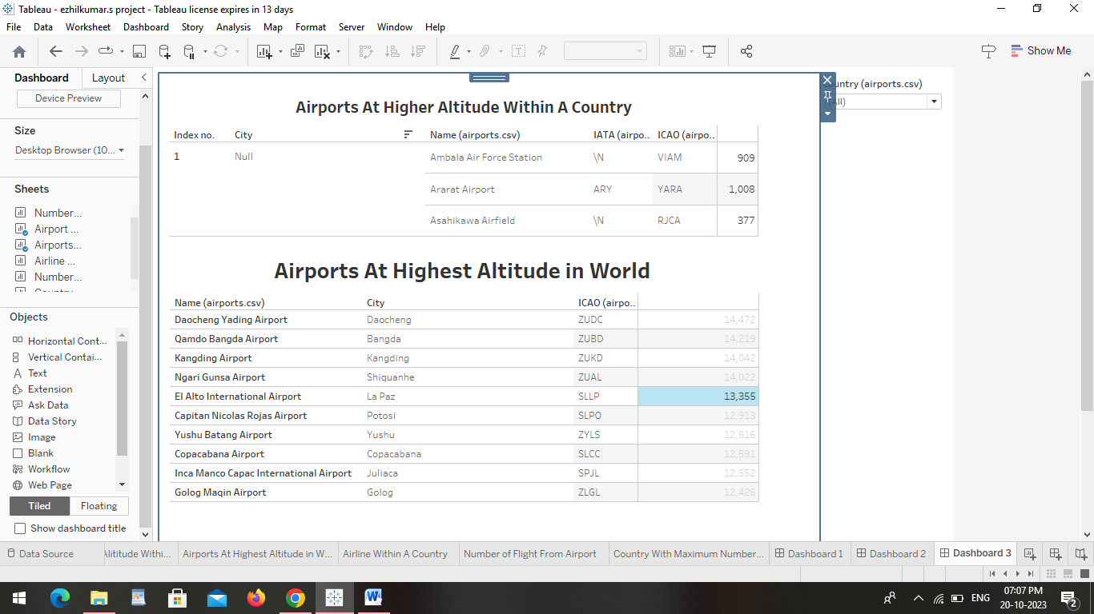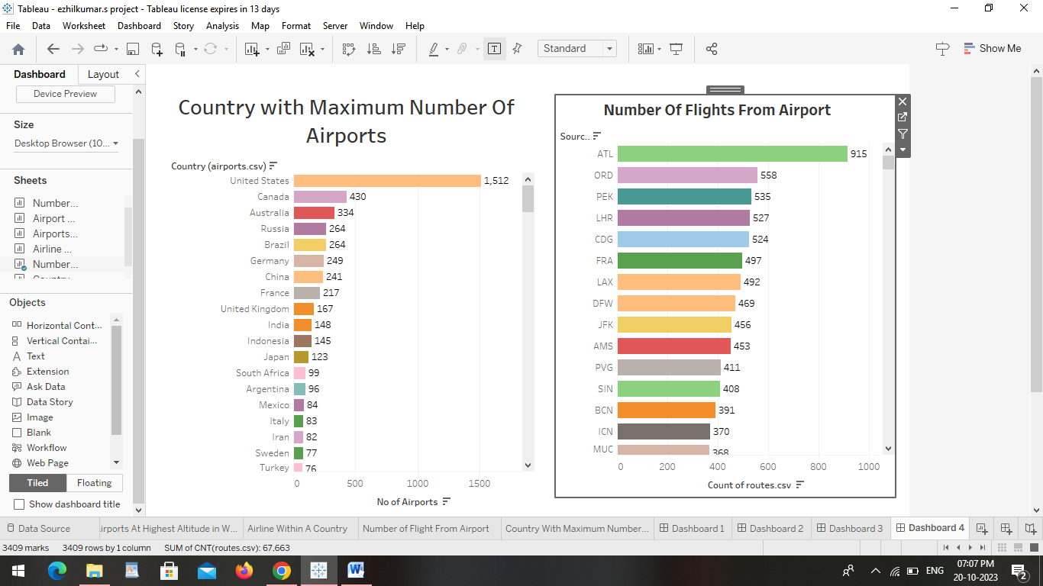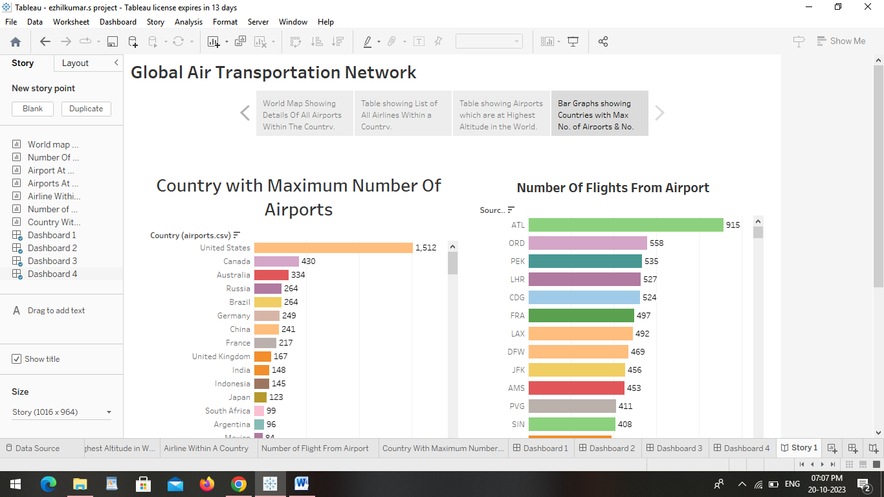Advantages :**

**1. High Speed**

**Air is the type of freight capable of traveling long distances in short periods of time. This makes this model an optimum choice if the client has an urgent need to ship a product or if their freight demands**[**special standards of protection**](https://www.curefirst.in/the-pharmaceutical-transportation/)**or acclimation. It is the quickest transport mode and is therefore ideal for long-distance transport of goods. It takes less time.**

**2. Fast Service**

**Air transportation offers convenient, reliable and fast services of transport. It is considered the cheapest way to ship peregrinated goods. It offers a standard, convenient, reliable and fast service.**

**3. Send almost everywhere your freight**

**In regions that are not readily accessible to other modes of transport, air transport is considered to be the only means of transport. Open to all regions, irrespective of land interference. A vast network of airlines covering nearly the whole globe is available for many airlines. This ensures that the package can be sent almost anywhere.**

**4. High Standard of Security**

**High standard of protection with a low risk of robbery and injury. Shipping by air has a high degree of security since airport safety restrictions on cargo are strictly enforced. Tightly controlled airport controls also minimise cargo theft and loss.**

**5. Natural Route**

**An aircraft can fly to any location without seeing any natural obstacles or barriers. Since customs formalities are easily compiled. It eliminates the need for more time to seek clearance. Air travel is used for relief operations during earthquakes, floods, accidents, and famines.**

**6. There is less need for heavy packaging**

**Air exports, in general, entail less hard packaging than ocean shipments. This ensures you save both time and money by not having to provide extra packaging services.**

**Disadvantages:**

### 1. Risky

**Air travel is the riskiest mode of transport, since there can be considerable losses to goods, customer and crews as a result of a minor crash. Compared to other means of travel, the risks of collisions are higher.**

### 2. Cost

**Air travel is considered to be the most expensive means of transportation. The cost of maintaining aircraft is higher and the costs for the building of aerodromes and avions are much higher. That’s why air travel is so expensive that it gets beyond ordinary people’s grasp.**

### 3. Some Product Limitation

**There is a whole variety of materials not suitable for such products, from explosives, gases, batteries, fired solids and liquids, which cannot be shipped by air to name but a few.**

### 4. Capacity for Small Carriage

**The aircraft have no room and therefore are not ideal for carriage of voluminous and cheaper materials. As is seen for rails, the load volume cannot be raised.**

### 5. Enormous investment

**Air travel calls for enormous spending in aerodrome building and servicing. It also calls for professional, qualified and qualified staff that need a significant investment.**

**Application:**

Modeling air transport networks aims airline companies to organize their routes in a cost-efficient way and therefore maximize their profits. Air transport network models are also the tool to investigate system robustness. They help to determine weaknesses of the system in case of various kinds of disruptions.[[4]](https://en.wikipedia.org/wiki/Air_Transport_Network#cite_note-Lordan-4)[[6]](https://en.wikipedia.org/wiki/Air_Transport_Network#cite_note-Hu-6) Once weaknesses are determined, a substitute node which can support all or part of the traffic load can be identified through the alternative strength for the pair.[[7]](https://en.wikipedia.org/wiki/Air_Transport_Network#cite_note-7)

An alternative application is modeling human disease networks. Air transport network is used by millions of people every day, therefore it plays key role in the spread of some infections, such as influenza or [SARS](https://en.wikipedia.org/wiki/SARS). In this sense air transport network is a transmitter similar to [sexual networks](https://en.wikipedia.org/wiki/Sexual_network), which is liable for the spread of AIDS and other sexually transmitted diseases

**Conclusion:**

Conclusion. Air India has established its position as India's largest and most effective air carrier on all fronts, according to the extensive studies done and information gathered.

**Future scope:**

The air transport network is a key infrastructure asset. It is the only worldwide passenger and cargo transportation network, providing an essential link between individual countries and the wider global economy

**UNLOCKING INSIGHTS INTO THE GLOBAL AIR TRANSPORTATION NETWORK WITH TABLEAU.**

1. **Introduction** 
   1. **Overview:**
   2. **Purpose:**
2. **Problem statement & design thinking**
   1. **Empathy map**
   2. **Ideation and brinstorming map**
3. **Result**
4. **Advantages & disadvantages**
5. **Application**
6. **Future scope**

**INTRODUCTION:**

This Global Air Transportation Network dataset is a comprehensive collection of information on airports, airlines and their routes. It contains information such as names, cities, countries, codes (IATA and ICAO) longitudes, latitudes and altitudes of airports across the world with detailed time zone and daylight saving time data. Additionally, this includes information about airlines including their IDs, name aliases, IATA and ICAO codes, callsigns country of origin and active/inactive status. Similarly, it also covers route details such as airline sources to destination airports along with essential details like codeshare stakeholder if any stops required during this journey along with the type of aircraft being used for that particular journey. This dataset has been compiled through meticulous labor by researchers all over the world to give you a comprehensive detail into air transportation networks from around the globe.

**OVERVIEW:**

The air transport network is a key infrastructure asset. It is the only worldwide passenger and cargo transportation network, providing an essential link between individual countries and the wider global economy.

**PURPOSE:**

IATA aims to be the force for value creation and innovation driving a safe, secure and profitable air transport industry that sustainably connects and enriches the world. IATA's mission is to represent, lead, and serve the airline industry.

**Empathy map:**



**Ideation and brainstorming map:**

**Result:Advantages :**

**1. High Speed**

**Air is the type of freight capable of traveling long distances in short periods of time. This makes this model an optimum choice if the client has an urgent need to ship a product or if their freight demands**[**special standards of protection**](https://www.curefirst.in/the-pharmaceutical-transportation/)**or acclimation. It is the quickest transport mode and is therefore ideal for long-distance transport of goods. It takes less time.**

**2. Fast Service**

**Air transportation offers convenient, reliable and fast services of transport. It is considered the cheapest way to ship peregrinated goods. It offers a standard, convenient, reliable and fast service.**

**3. Send almost everywhere your freight**

**In regions that are not readily accessible to other modes of transport, air transport is considered to be the only means of transport. Open to all regions, irrespective of land interference. A vast network of airlines covering nearly the whole globe is available for many airlines. This ensures that the package can be sent almost anywhere.**

**4. High Standard of Security**

**High standard of protection with a low risk of robbery and injury. Shipping by air has a high degree of security since airport safety restrictions on cargo are strictly enforced. Tightly controlled airport controls also minimise cargo theft and loss.**

**5. Natural Route**

**An aircraft can fly to any location without seeing any natural obstacles or barriers. Since customs formalities are easily compiled. It eliminates the need for more time to seek clearance. Air travel is used for relief operations during earthquakes, floods, accidents, and famines.**

**6. There is less need for heavy packaging**

**Air exports, in general, entail less hard packaging than ocean shipments. This ensures you save both time and money by not having to provide extra packaging services.**

**Disadvantages:**

### 1. Risky

**Air travel is the riskiest mode of transport, since there can be considerable losses to goods, customer and crews as a result of a minor crash. Compared to other means of travel, the risks of collisions are higher.**

### 2. Cost

**Air travel is considered to be the most expensive means of transportation. The cost of maintaining aircraft is higher and the costs for the building of aerodromes and avions are much higher. That’s why air travel is so expensive that it gets beyond ordinary people’s grasp.**

### 3. Some Product Limitation

**There is a whole variety of materials not suitable for such products, from explosives, gases, batteries, fired solids and liquids, which cannot be shipped by air to name but a few.**

### 4. Capacity for Small Carriage

**The aircraft have no room and therefore are not ideal for carriage of voluminous and cheaper materials. As is seen for rails, the load volume cannot be raised.**

### 5. Enormous investment

**Air travel calls for enormous spending in aerodrome building and servicing. It also calls for professional, qualified and qualified staff that need a significant investment.**

**Application:**

Modeling air transport networks aims airline companies to organize their routes in a cost-efficient way and therefore maximize their profits. Air transport network models are also the tool to investigate system robustness. They help to determine weaknesses of the system in case of various kinds of disruptions.[[4]](https://en.wikipedia.org/wiki/Air_Transport_Network#cite_note-Lordan-4)[[6]](https://en.wikipedia.org/wiki/Air_Transport_Network#cite_note-Hu-6) Once weaknesses are determined, a substitute node which can support all or part of the traffic load can be identified through the alternative strength for the pair.[[7]](https://en.wikipedia.org/wiki/Air_Transport_Network#cite_note-7)

An alternative application is modeling human disease networks. Air transport network is used by millions of people every day, therefore it plays key role in the spread of some infections, such as influenza or [SARS](https://en.wikipedia.org/wiki/SARS). In this sense air transport network is a transmitter similar to [sexual networks](https://en.wikipedia.org/wiki/Sexual_network), which is liable for the spread of AIDS and other sexually transmitted diseases

**Conclusion:**

Conclusion. Air India has established its position as India's largest and most effective air carrier on all fronts, according to the extensive studies done and information gathered.

**Future scope:**

The air transport network is a key infrastructure asset. It is the only worldwide passenger and cargo transportation network, providing an essential link between individual countries and the wider global economy